**Project Execution – Step by Step Process**

1. **SQL Development :**

SELECT

PAPF.PERSON_NUMBER AS EMPLOYEE_CODE ,

PPNF.FIRST_NAME ,

PPNF.FULL_NAME ,

TO_CHAR(PP.DATE_OF_BIRTH,'DD-MONTH-YYYY') DATE_OF_BIRTH ,

PEA.EMAIL_ADDRESS ,

TO_CHAR(PPS.DATE_START,'DD-MONTH-YYYY') DATE_OF_JOINING ,

HOUFT.NAME DEPARTMENT ,

CASE

WHEN TO_CHAR(PP.DATE_OF_BIRTH, 'MM-DD') = TO_CHAR(SYSDATE, 'MM-DD') THEN 'Birthday'

WHEN TO_CHAR(PPS.DATE_START, 'MM-DD') = TO_CHAR(SYSDATE, 'MM-DD') THEN

CASE

WHEN FLOOR(MONTHS_BETWEEN(SYSDATE, PPS.DATE_START) / 12) = 1 THEN '1st Work Anniversary'

WHEN FLOOR(MONTHS_BETWEEN(SYSDATE, PPS.DATE_START) / 12) = 2 THEN '2nd Work Anniversary'

WHEN FLOOR(MONTHS_BETWEEN(SYSDATE, PPS.DATE_START) / 12) = 3 THEN '3rd Work Anniversary'

ELSE TO_CHAR(FLOOR(MONTHS_BETWEEN(SYSDATE, PPS.DATE_START) / 12)) || 'th Work Anniversary'

END

ELSE NULL

END AS INFO

FROM

PER_ALL_PEOPLE_F PAPF ,

PER_PERSON_NAMES_F PPNF ,

PER_PERSONS PP ,

PER_EMAIL_ADDRESSES PEA ,

PER_PERIODS_OF_SERVICE PPS ,

PER_ALL_ASSIGNMENTS_M PAAM ,

HR_ORGANIZATION_UNITS_F_TL HOUFT

WHERE

1=1

AND PAPF.PERSON_ID = PPNF.PERSON_ID

AND TRUNC(SYSDATE) BETWEEN PAPF.EFFECTIVE_START_DATE AND PAPF.EFFECTIVE_END_DATE

AND TRUNC(SYSDATE) BETWEEN PPNF.EFFECTIVE_START_DATE AND PPNF.EFFECTIVE_END_DATE

AND PPNF.NAME_TYPE='GLOBAL'

AND PAPF.PERSON_ID = PP.PERSON_ID

AND PAPF.PERSON_ID = PEA.PERSON_ID

AND PEA.EMAIL_TYPE = 'W1'

AND PAPF.PERSON_ID = PAAM.PERSON_ID

AND PAAM.ASSIGNMENT_TYPE = 'E'

AND PAAM.PRIMARY_FLAG = 'Y'

AND PAAM.ASSIGNMENT_STATUS_TYPE = 'ACTIVE'

AND PAAM.EFFECTIVE_LATEST_CHANGE = 'Y'

AND TRUNC(SYSDATE) BETWEEN PAAM.EFFECTIVE_START_DATE AND PAAM.EFFECTIVE_END_DATE

AND PAAM.PERIOD_OF_SERVICE_ID = PPS.PERIOD_OF_SERVICE_ID

AND PAAM.ORGANIZATION_ID = HOUFT.ORGANIZATION_ID(+)

AND TRUNC(SYSDATE) BETWEEN HOUFT.EFFECTIVE_START_DATE AND HOUFT.EFFECTIVE_END_DATE

AND HOUFT.LANGUAGE = 'US'

AND (

TO_CHAR(PP.DATE_OF_BIRTH, 'MM-DD') = TO_CHAR(SYSDATE, 'MM-DD')

OR

TO_CHAR(PPS.DATE_START, 'MM-DD') = TO_CHAR(SYSDATE, 'MM-DD')

)

AND PPS.DATE_START <> TRUNC(SYSDATE)

ORDER BY

HOUFT.NAME,PAPF.PERSON_NUMBER,PPNF.FULL_NAME

**Query Explanation**

The SQL query is used to fetch employee details for those celebrating either a birthday or a work anniversary on the current day.

**SELECT Clause:**

* PAPF.PERSON_NUMBER: Employee code.
* PPNF.FIRST_NAME, PPNF.FULL_NAME: Employee names.
* TO_CHAR(PP.DATE_OF_BIRTH,'DD-MONTH-YYYY'): Formats the date of birth.
* PEA.EMAIL_ADDRESS: Employee's work email.
* TO_CHAR(PPS.DATE_START,'DD-MONTH-YYYY'): Formats date of joining.
* HOUFT.NAME: Department name.
* CASE block: Determines if today is the employee's birthday or work anniversary and returns a suitable label.

**FROM Clause:**

* Joins multiple HCM tables:
  + PER_ALL_PEOPLE_F, PER_PERSON_NAMES_F, PER_PERSONS: To get personal and identification details.
  + PER_EMAIL_ADDRESSES: To get official email.
  + PER_PERIODS_OF_SERVICE: For joining dates.
  + PER_ALL_ASSIGNMENTS_M: For employment and organizational data.
  + HR_ORGANIZATION_UNITS_F_TL: For department info.

**WHERE Clause:**

* Ensures only active and current employees are selected using date filters and flags.
* Filters:
  + Employee and name details must be effective as of today.
  + Email type must be work email ('W1').
  + Assignment must be primary, active, and of type 'E' (Employee).
  + Department name is retrieved based on organization ID.
  + TO_CHAR(..., 'MM-DD') = TO_CHAR(SYSDATE, 'MM-DD'): This compares birthday and DOJ with today's date.
  + PPS.DATE_START <> TRUNC(SYSDATE): To exclude today as the first day of employment (not considered anniversary).

**ORDER BY Clause:**

* Sorts output by Department, Employee Code, and Full Name for better readability.

**Execution of SQL**

**1.Login into ORACLE HCM fusion application by clicking on this link**

**https://eudr-dev27.dsfa.oraclepdemos.com/analytics/saw.dll?bipublisherEntry**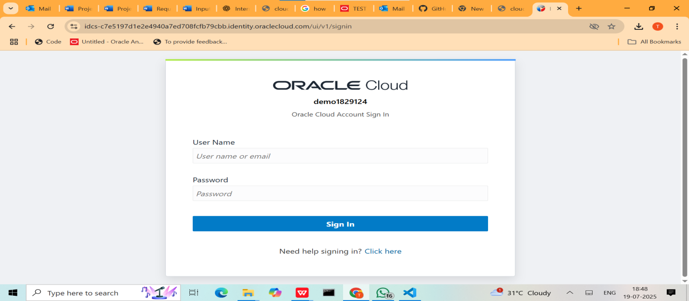

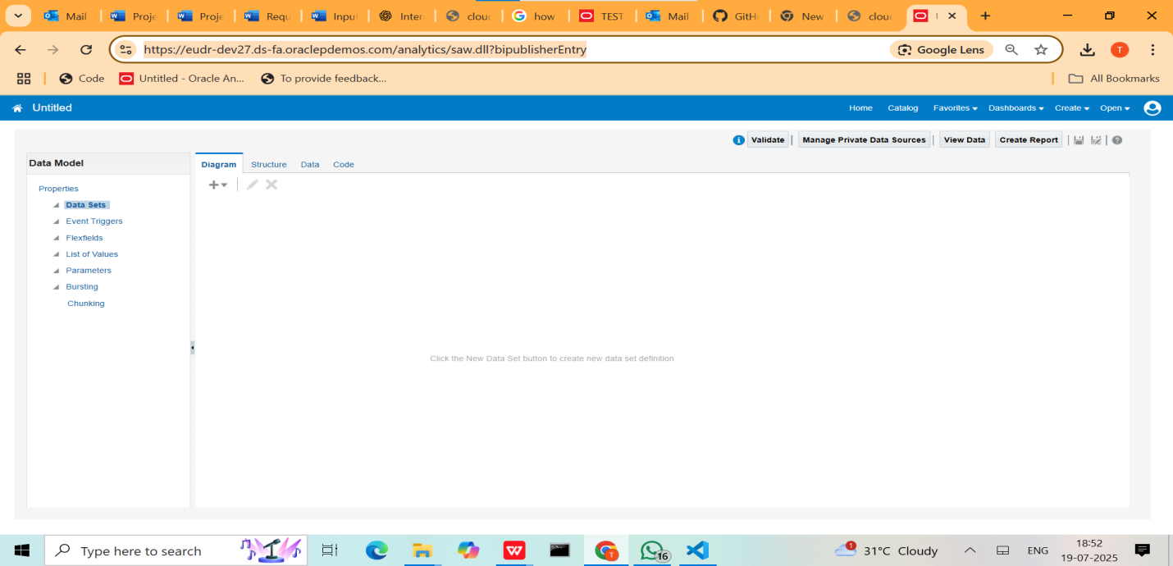

**2.Click on Create and select Data Model**

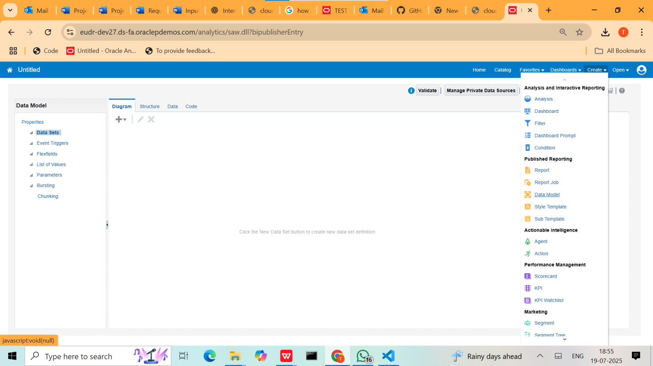

**3.Click on + button and tap on SQL Query**

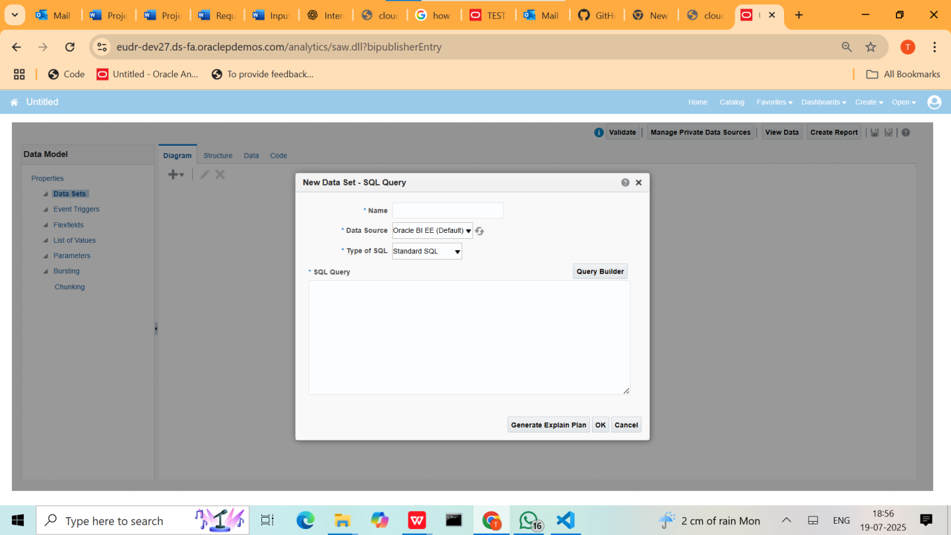

**4.Name the task and select data source as “APPLICATIONDB_HCM” and paste the query we written on notepad++ or vscode**

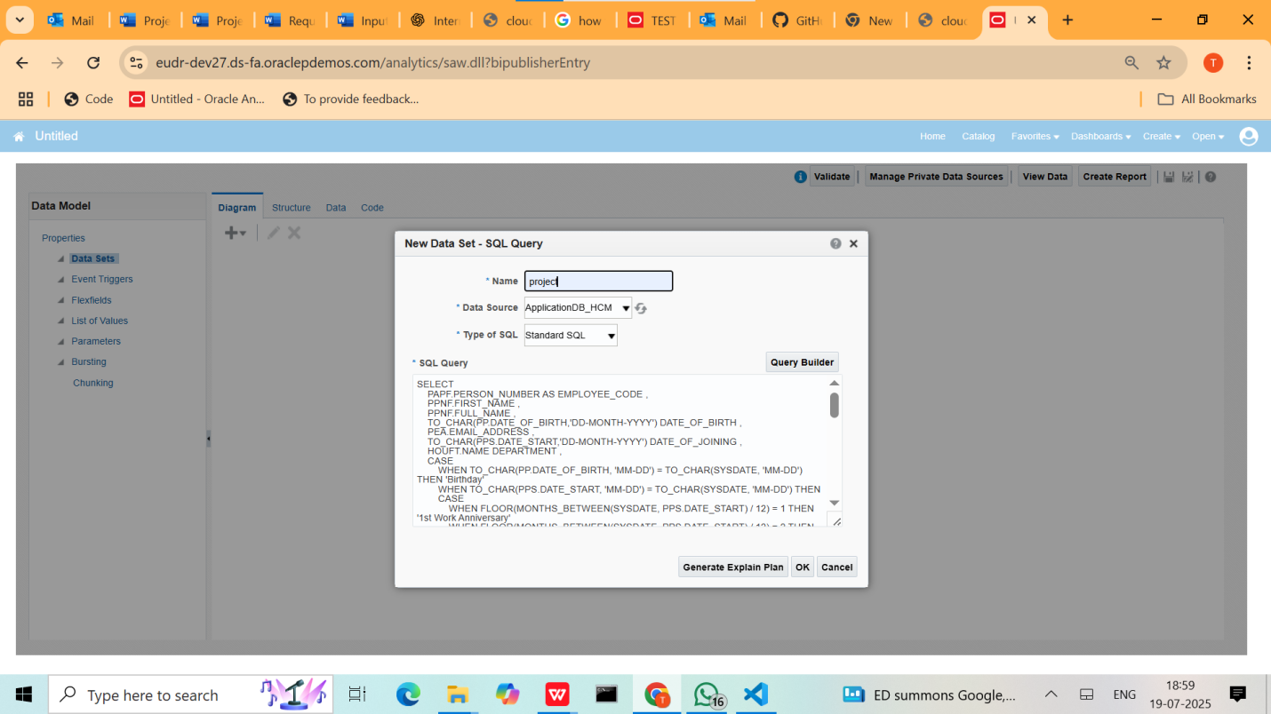

**5. press on it will create data model and data model contains the exact fields we retrieved by the SQL**  **Query According to the Report**

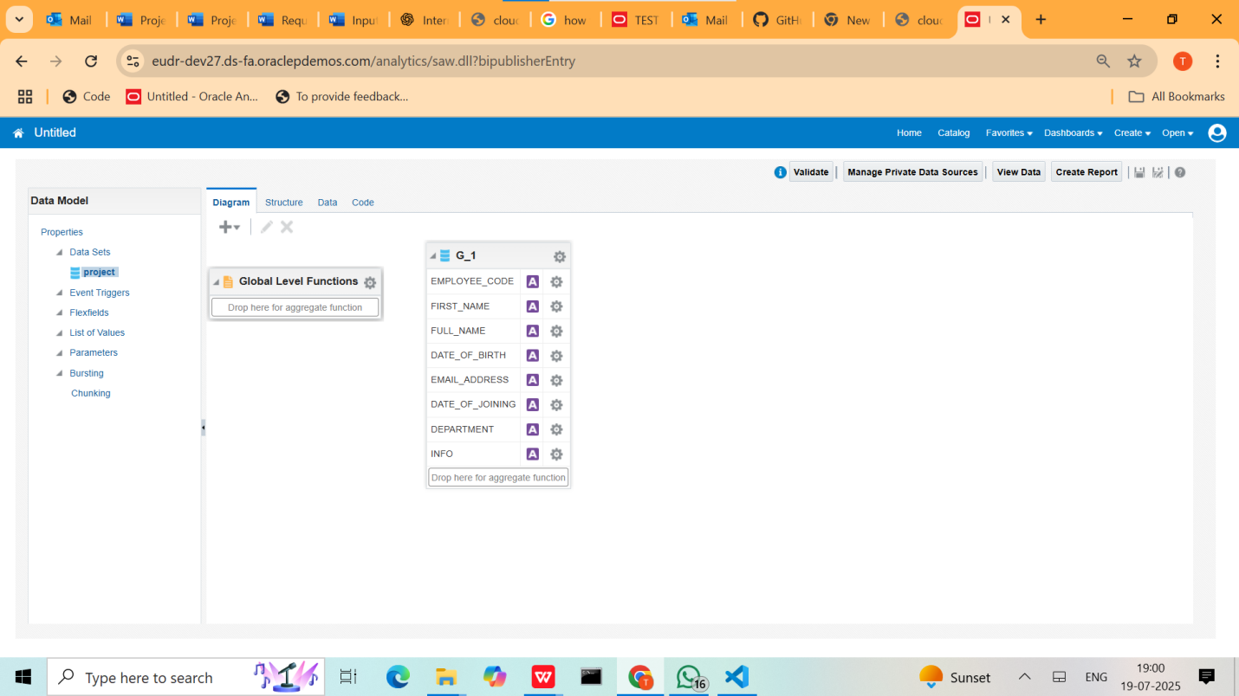

**5. then click on data and select view on tableview**

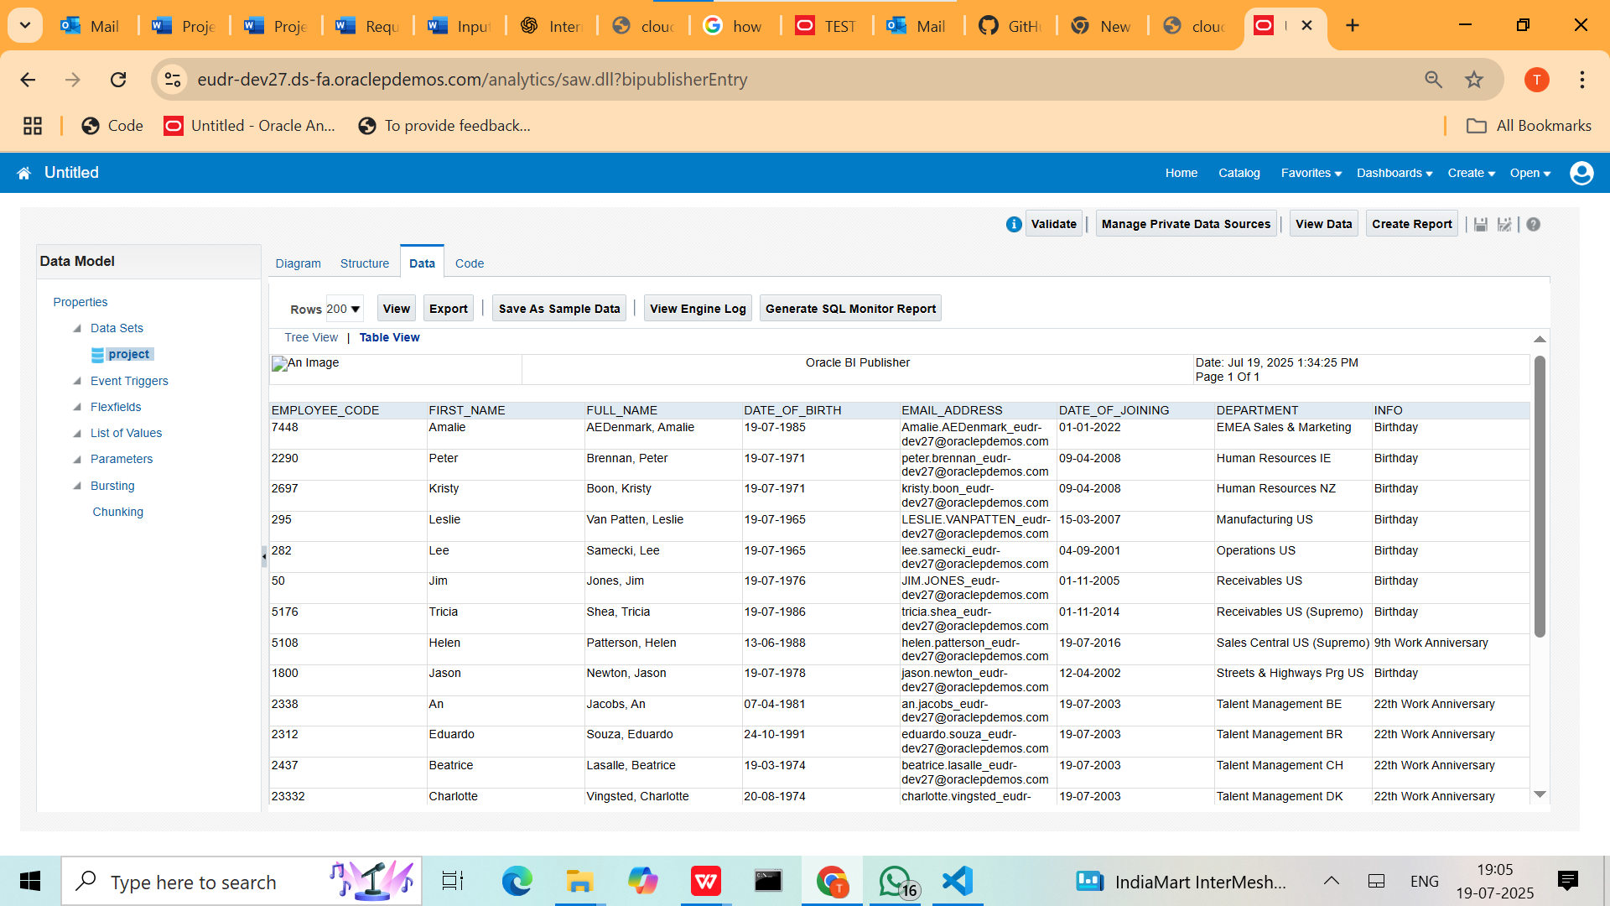

**6. Then we will do bursting for automatic daily schedule mail to dedicated HR or client who required**

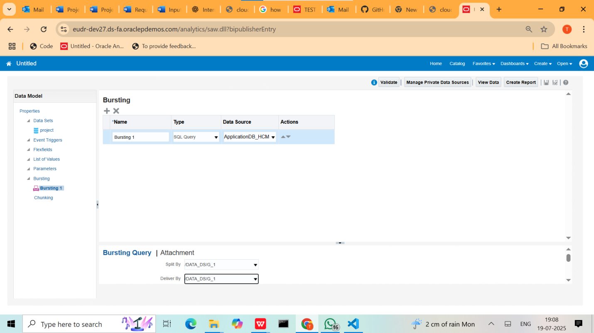

**7.Attach the Bursting Query Here**

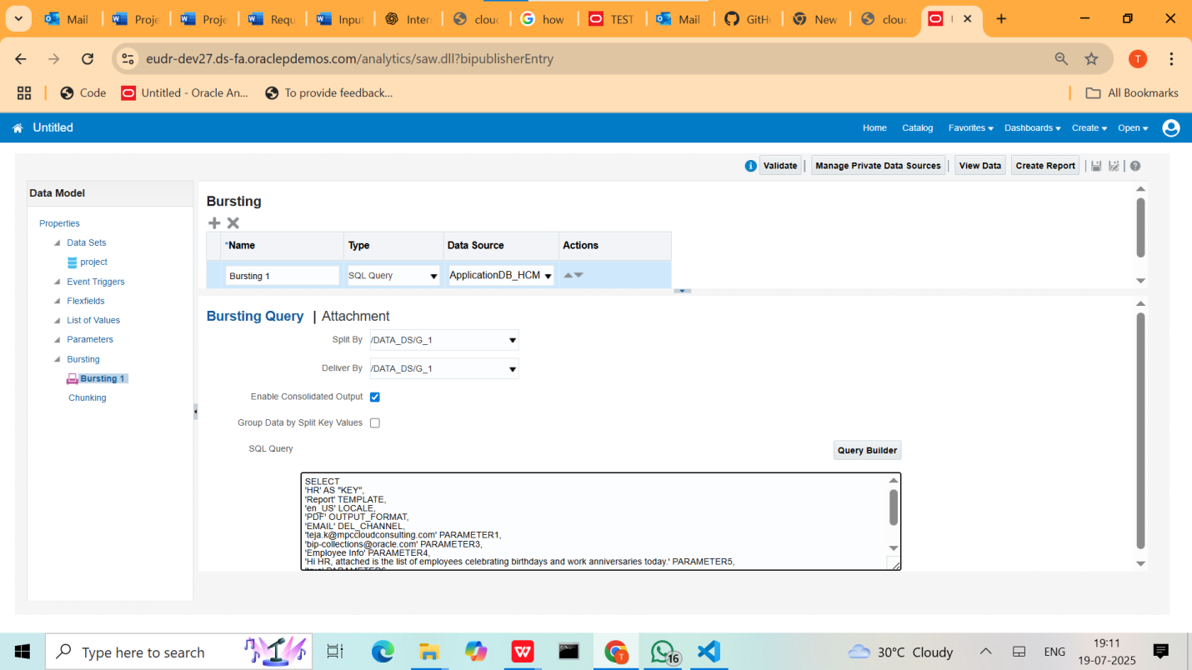

SELECT

'HR' AS "KEY",

'Report' TEMPLATE,

'en_US' LOCALE,

'PDF' OUTPUT_FORMAT,

'EMAIL' DEL_CHANNEL,

'[teja.k@mpccloudconsulting.com](mailto:teja.k@mpccloudconsulting.com)' PARAMETER1,

'[bip-collections@oracle.com](mailto:bip-collections@oracle.com)' PARAMETER3,

'Employee Info' PARAMETER4,

'Hi HR, attached is the list of employees celebrating birthdays and work anniversaries today.' PARAMETER5,

'true' PARAMETER6,

'[donotreply@mycompany.com](mailto:donotreply@mycompany.com)' PARAMETER7

FROM

DUAL

### 

### **Field-by-Field Explanation**

|  |  |
| --- | --- |
| **Field** | **Meaning** |
| 'HR' AS "KEY" | A unique key to identify the recipient or group. It should match the key in the main data model output (used to link data with bursting rule). |
| 'Report' TEMPLATE | The name of the **report layout/template** to use for generating the output. |
| 'en_US' LOCALE | Locale setting for the report (language, date/time formats). en_US = English (United States). |
| 'PDF' OUTPUT_FORMAT | The output format of the report. Other options include RTF, HTML, Excel, etc. |
| 'EMAIL' DEL_CHANNEL | Delivery channel. Here it specifies **email**. Other options include FTP, Printer, etc. |
| '[teja.k@mpccloudconsulting.com](mailto:teja.k@mpccloudconsulting.com)' PARAMETER1 | **To Address** – The email address where the report will be sent. |
| '[bip-collections@oracle.com](mailto:bip-collections@oracle.com)' PARAMETER3 | **From Address** – The email address that will appear in the "From" field. |
| 'Employee Info' PARAMETER4 | **Email Subject** – Subject line of the email. |
| 'Hi HR, attached is the list... ' PARAMETER5 | **Email Body** – The actual message body of the email. |
| 'true' PARAMETER6 | **Attachment flag** – If 'true', the report will be sent as an attachment. If 'false', it will be in the body. |
| '[donotreply@mycompany.com](mailto:donotreply@mycompany.com)' PARAMETER7 | **Reply-to Address** – This controls where replies go. Usually set to a no-reply address. |

### **Use in BI Publisher (BIP)**

In Oracle BI Publisher:

* This query is defined in the **Bursting Control File**.
* It connects the **data output (KEY)** with **report delivery** metadata.
* You assign this SQL to your report in the bursting configuration.

### **Example Scenario**

When your daily **Birthday & Work Anniversary Report** runs:

* It generates the output in PDF format.
* Sends it as an email **to HR (teja.k@mpccloud...)**.
* From **[bip-collections@oracle.com](mailto:bip-collections@oracle.com)**.
* Subject: **"Employee Info"**.
* Body: **“Hi HR, attached is the list…”**.
* The PDF report is **attached** to the email.
* Any replies go to **[donotreply@mycompany.com](mailto:donotreply@mycompany.com)**.

**7.Then Click on Create Report and before report create a RTF Template by exporting the xml fike into BI Publisher in Word ( before we have to downloading the BI Publisher ADF )**

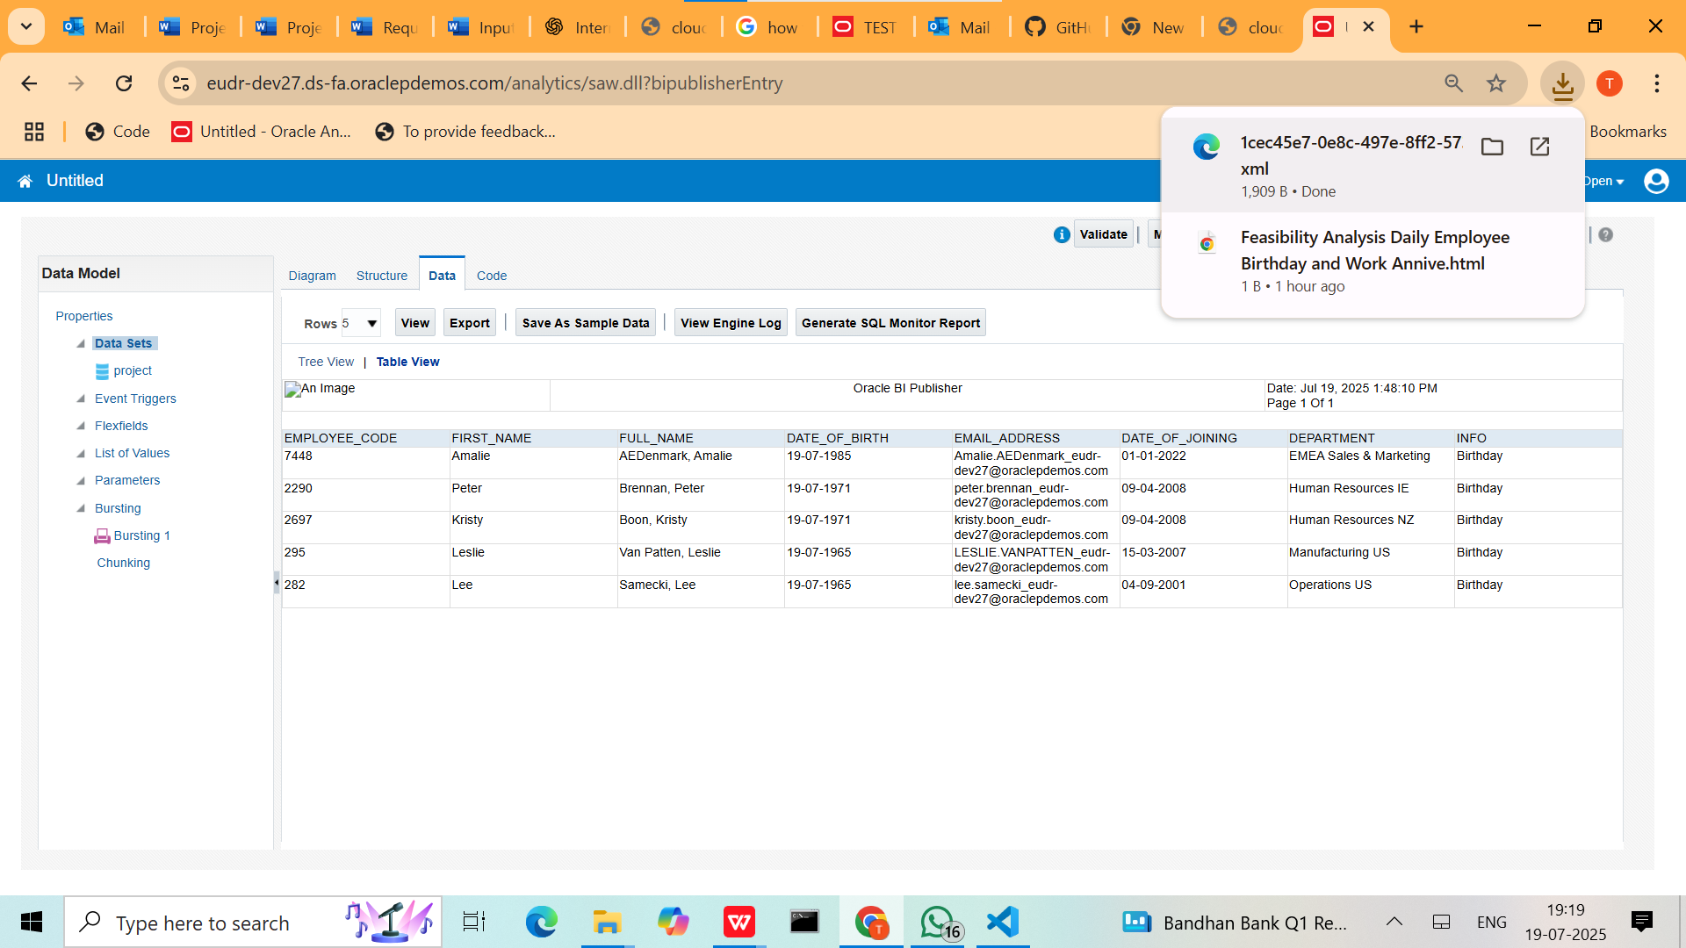

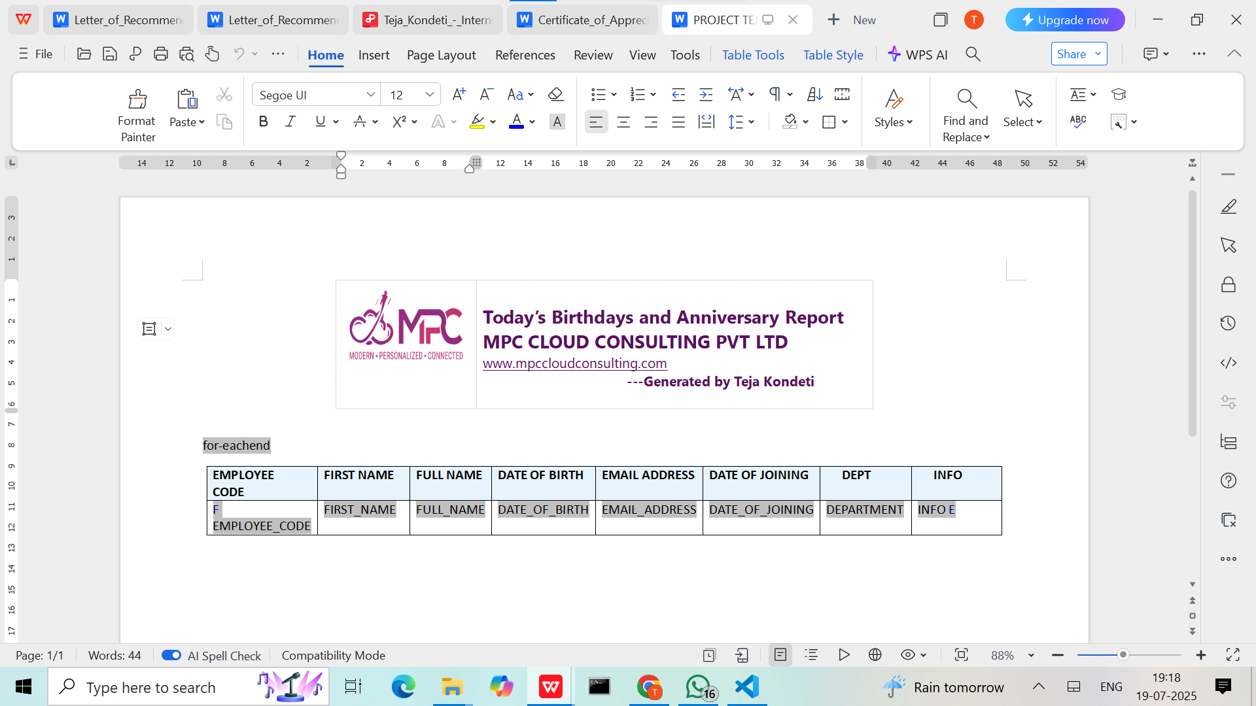

**8. Click on Create Report and then the select “USE DATAMODEL” which we had created and select Report Editor**

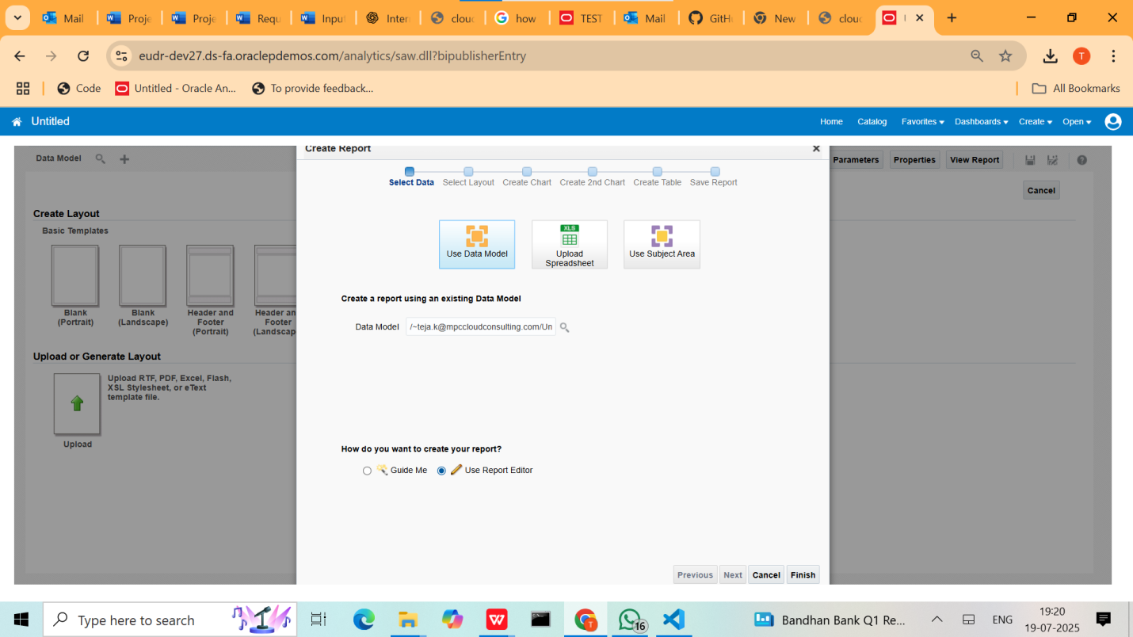

**9.click on Finish and the upload the RTF Template which we created**

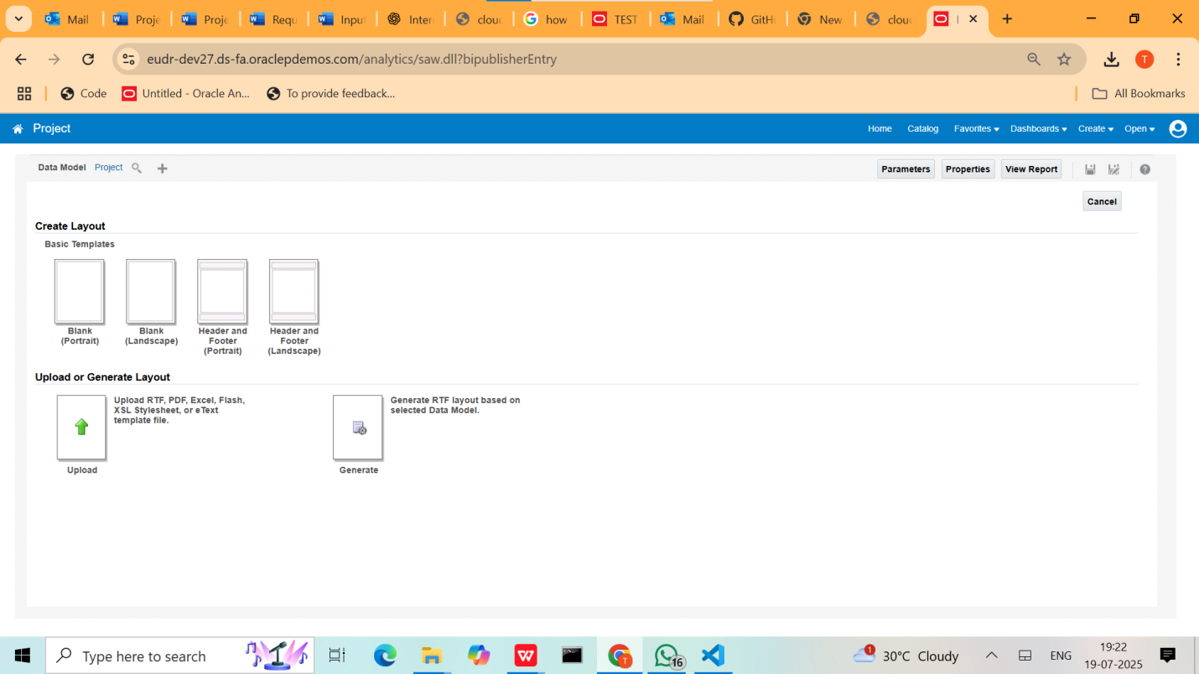

1. **After Uploading Template and then click on view report then the report comes** 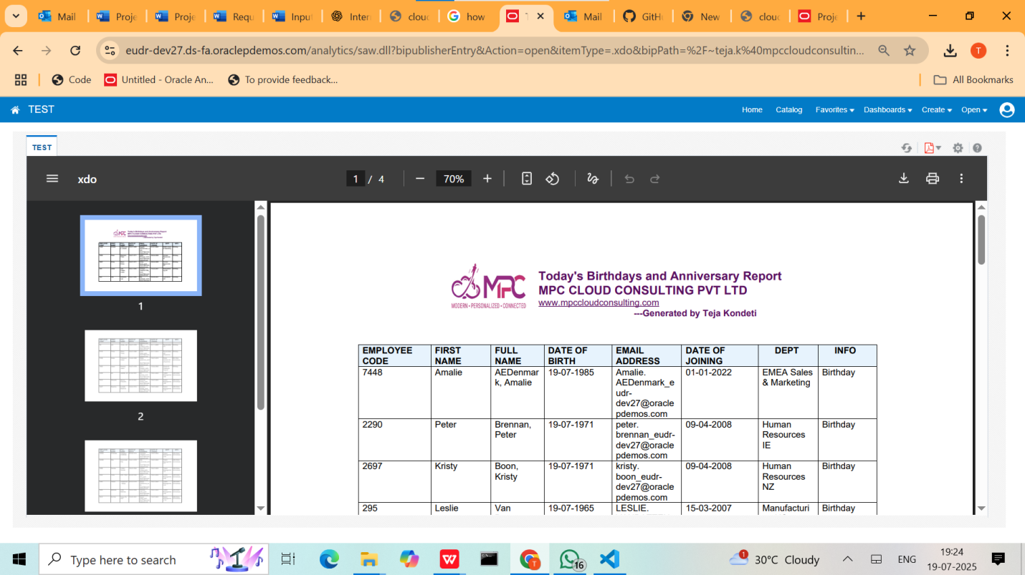
2. **Then we have to schedule the project**

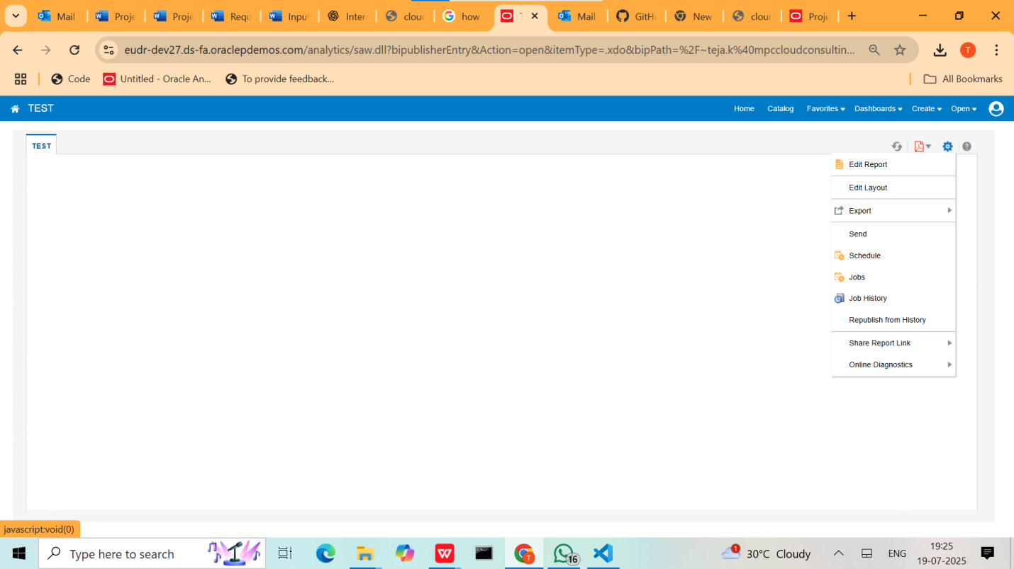

1. **Enable the Frequency to Daily to Trigger the Mail Accordingly**

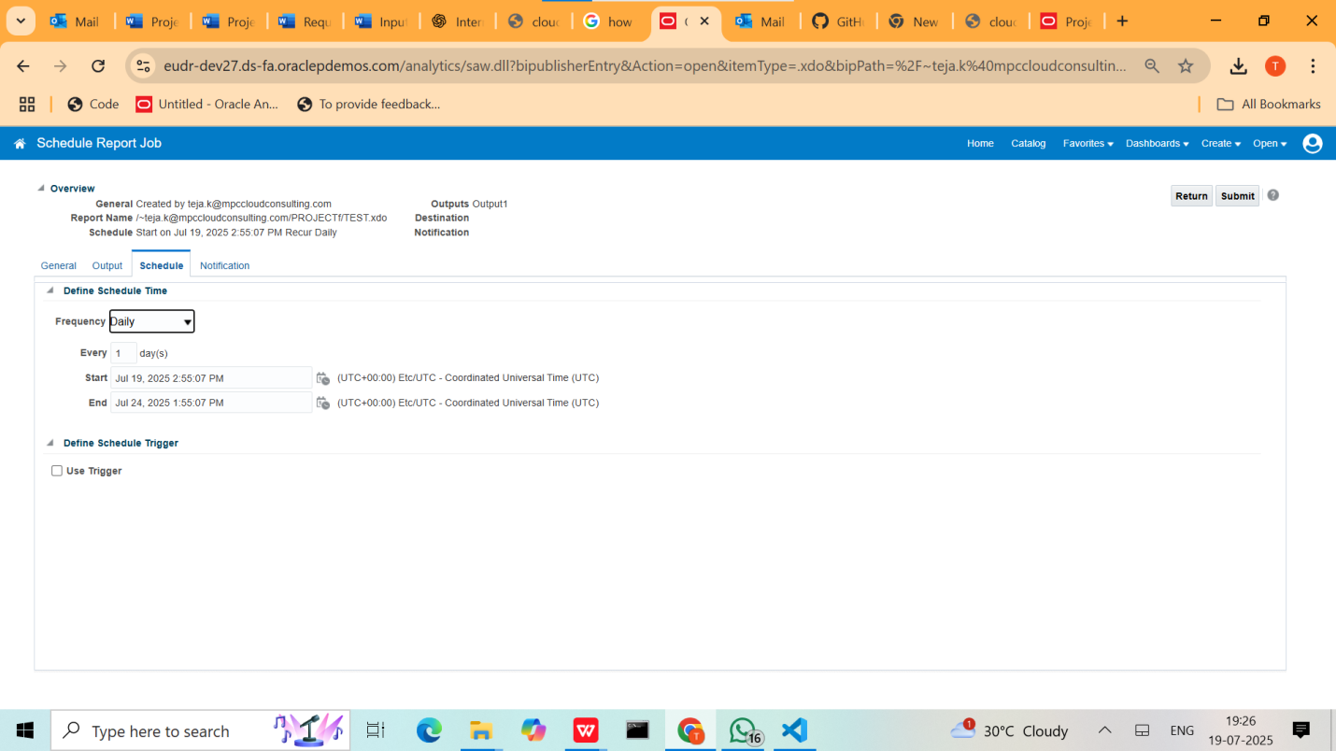

1. **Then we receive the mail daily in outlook or what else the to section ( mail ) in the bursting query**

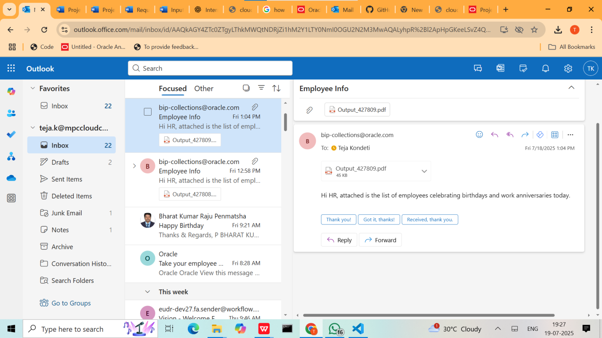

**At Last I am Uploading the sample report downloaded from the mail which was sent by my project you can refer the following**